**DEPLOYMENT OF APP IN IBM CLOUD**

|  |  |
| --- | --- |
| Date | 09 November 2022 |
| Team ID | PNT2022TMID22996 |
| Project Name | Plasma Donor Application |

**JOB PORTAL DOCKER DESKTOP:**

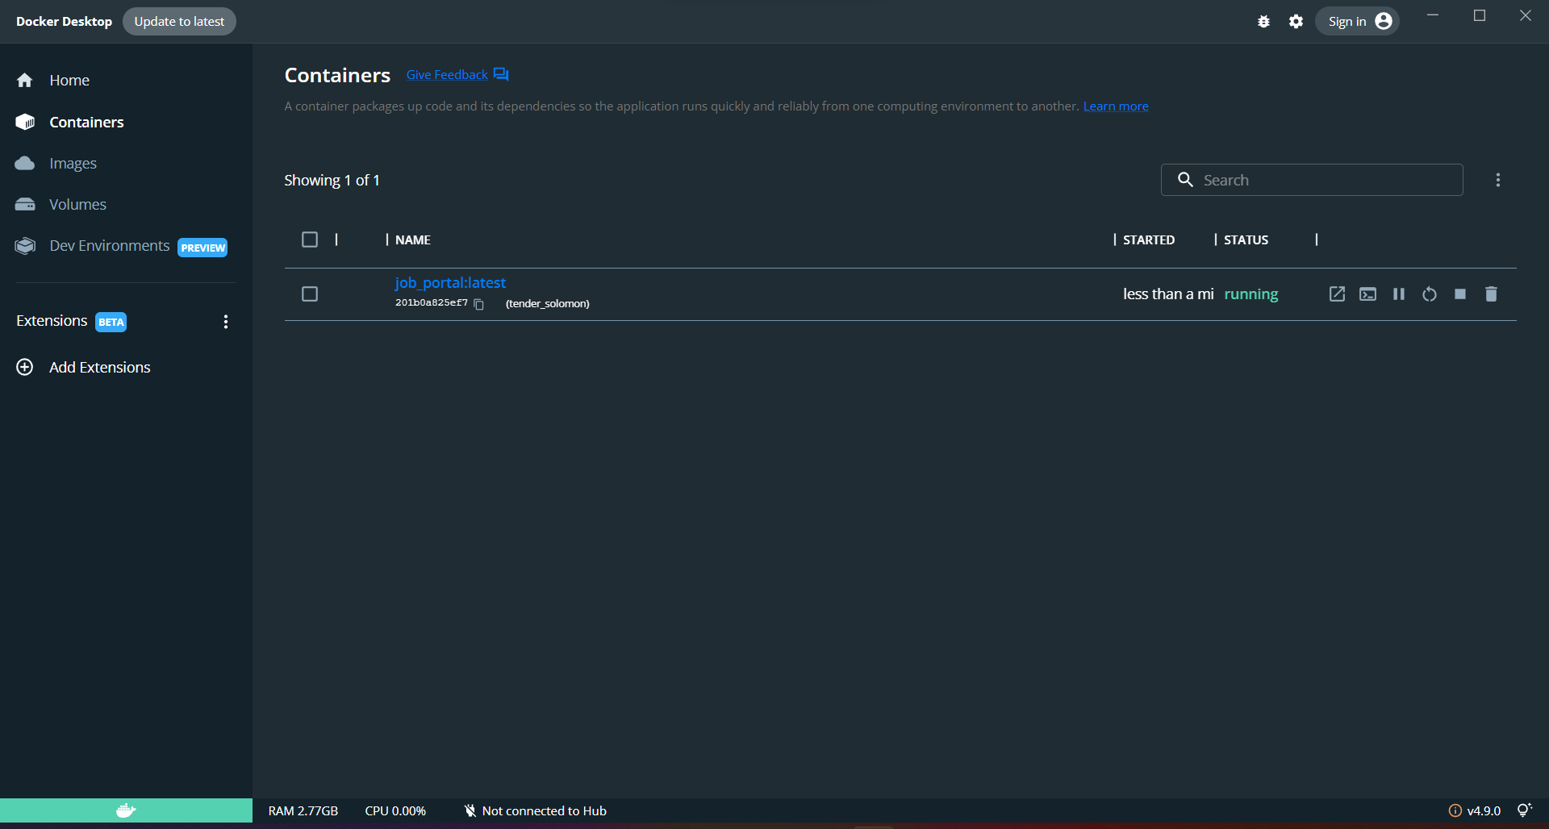

**HOSTED APP WITH DOCKER DESKTOP:**

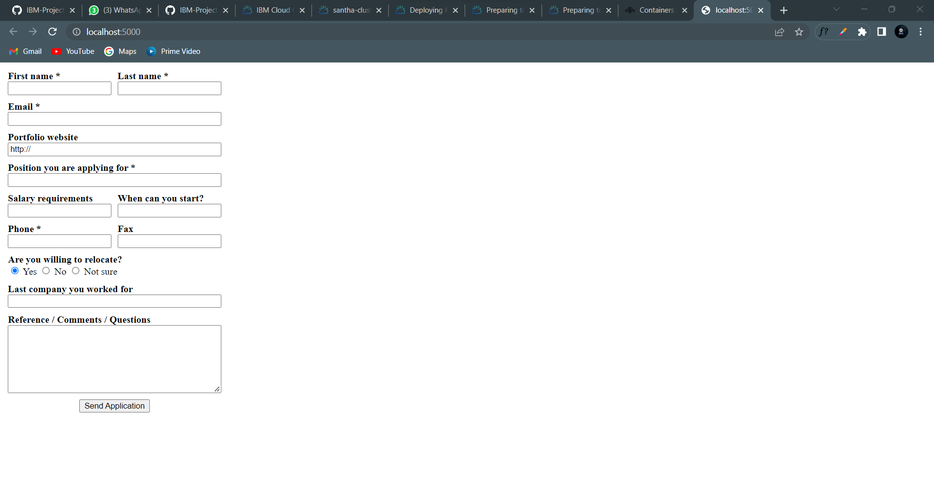

**IBM REGISTRY:**

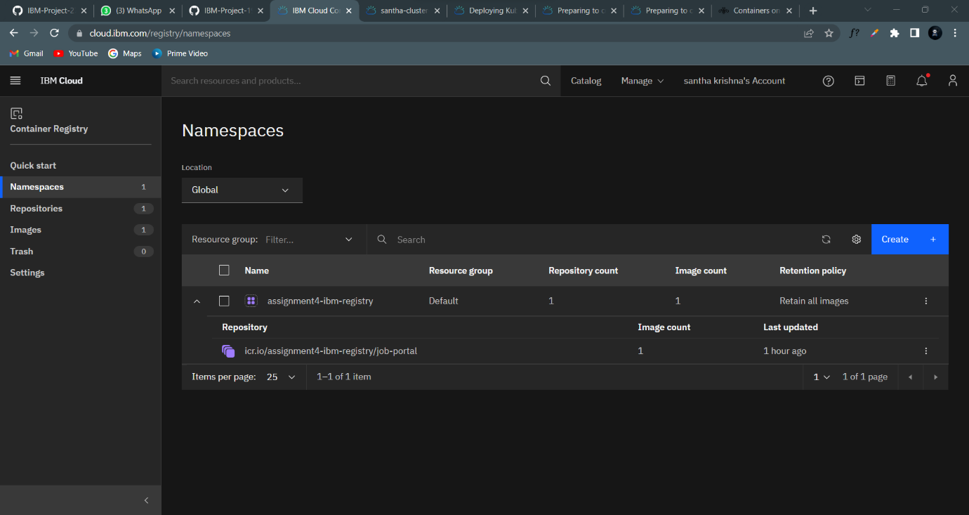

**KUBERNETES CLUSTER PENDING:**

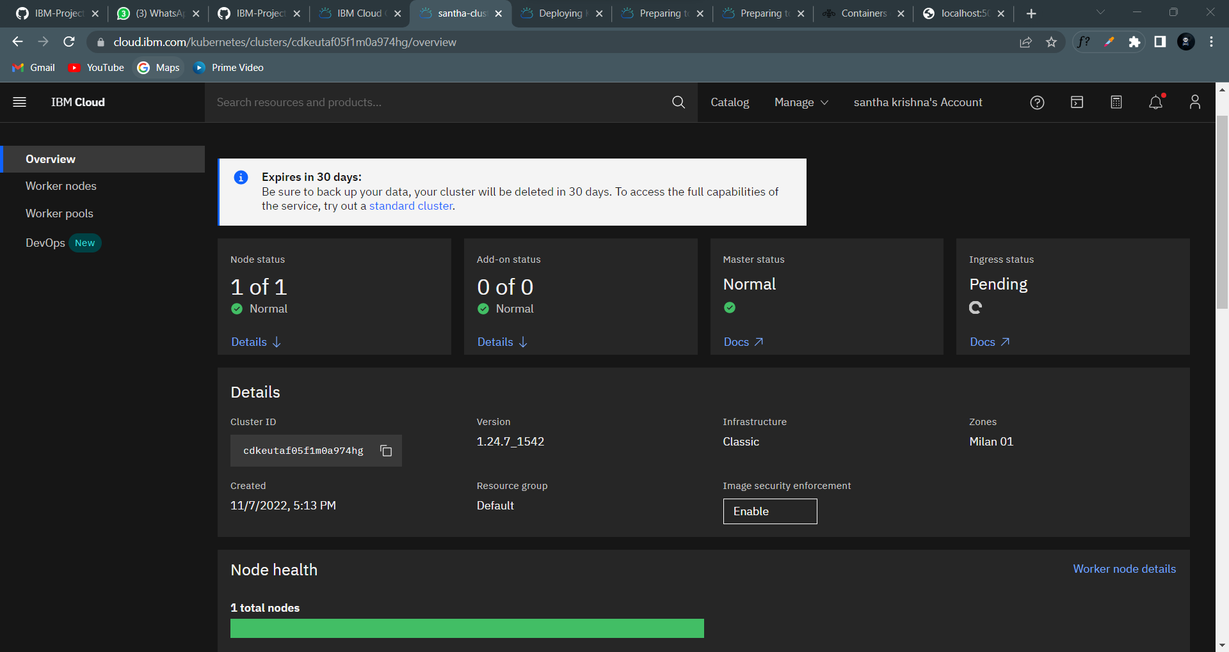

**KUBERNETES CLUSTER COMPLETED:**

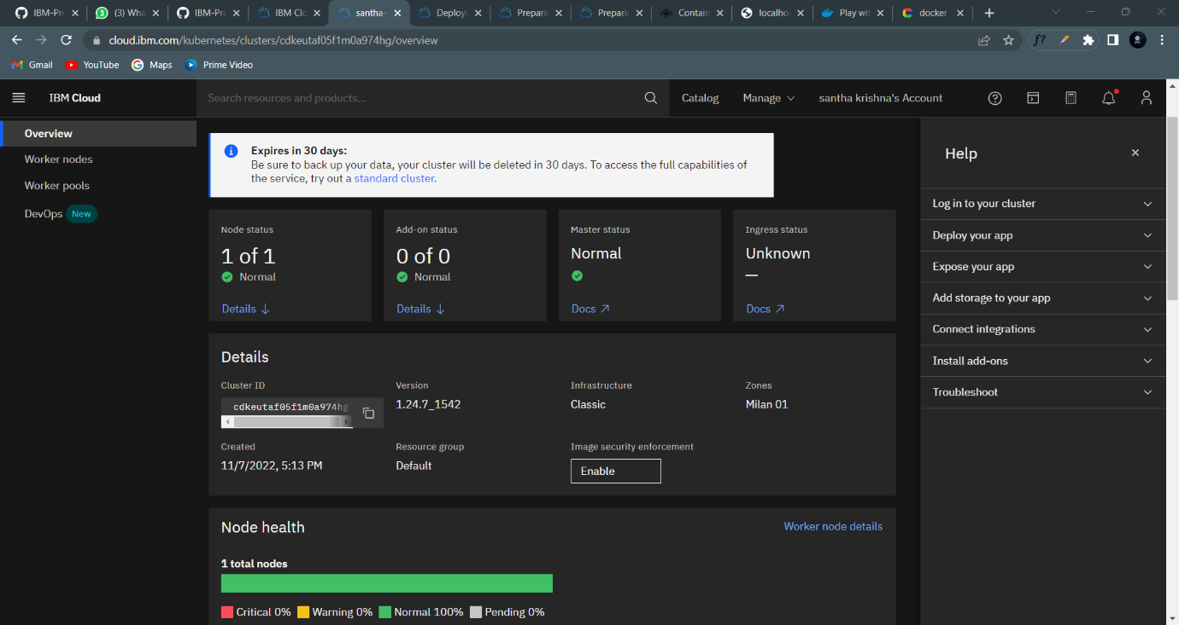

**NODE PORT:**

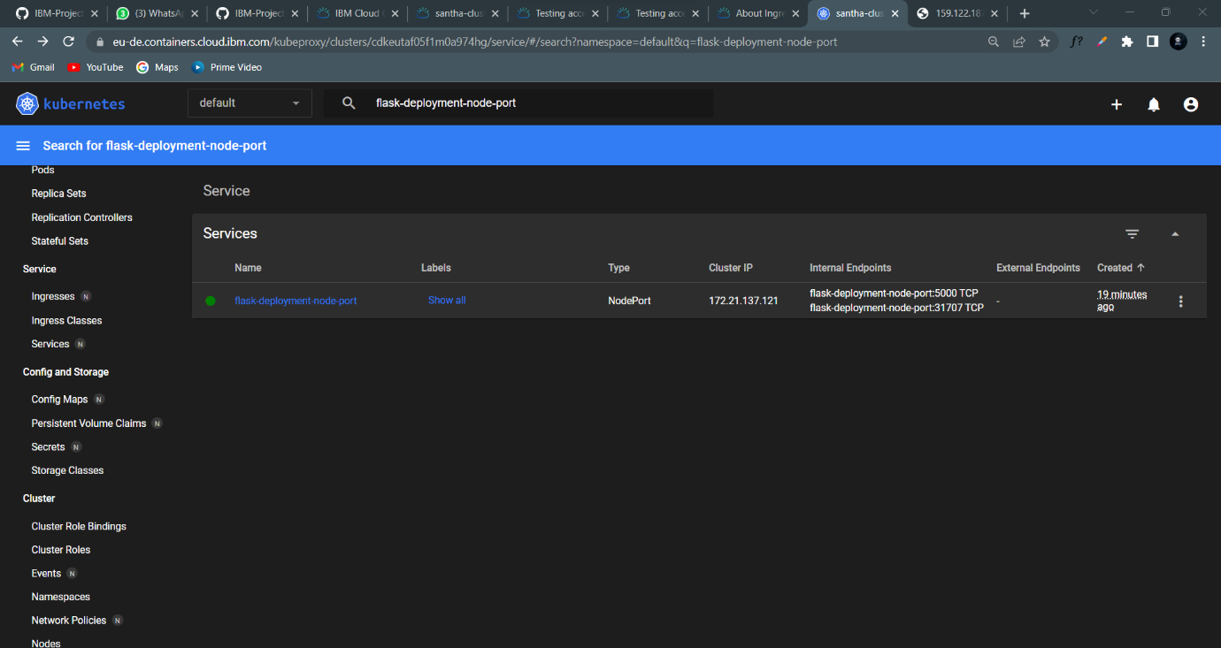

**KUBERNETES WORKER PUBLIC IP:**

